April 23, 2020

Governor Mike DeWine
Riffe Center, 30th Floor
77 South High Street
Columbus, Ohio 43215-6117

Governor DeWine,

Thank you for the opportunity to share with you a picture of what it looks like for construction workers in Ohio to work safely and to stay healthy during this pandemic. As essential employers who already required safe practices in our work environment as a rule, ABC members have a wealth of experience to share with you about working safely and staying healthy, which are and have always been, top priorities for Associated Builders and Contractors.

Our members have consistently followed the federal, state and local laws defining safe practices including OSHA regulations, U.S. Department of Labor laws, Ohio Workers Compensation and more.

ABC also has our own safety program we call the Safety Training and Evaluation Process (STEP). Each of Ohio’s chapters participates in the program. Our national organization has an excellent example of the depth of this certification procedure on their website.

Attached for your information is a two-page outline of the health and safety best practices hundreds of our members are already using to protect against COVID-19. The outline represents the contents of a new website www.OhioHealthyConstruction.org. The website offers employers detailed information and guidelines for implementation of these practices from Federal and State agencies and provides the opportunity for them to pledge to use them. Already 503 contractors, 85 suppliers and 131 consultants have taken the pledge.

ABC of Ohio offers this website and any materials that would be helpful to your administration as the proven template for construction safety. Please feel free to share it as an example for other industries and states to follow.

We welcome your questions and are grateful for your leadership,

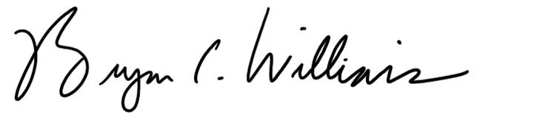 Beth Lear
Bryan C. Williams Beth Lear
President, ABC of Ohio VP of Government Affairs
(614) 359-4846 (614)725-6018
bwilliams@abcofohio.org blear@abcofohio.org

